HEBRON NJROTC

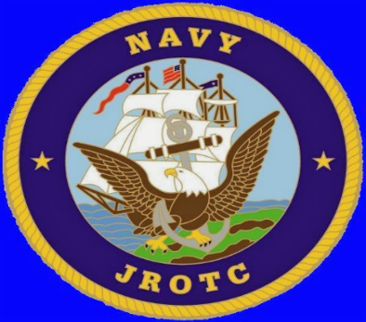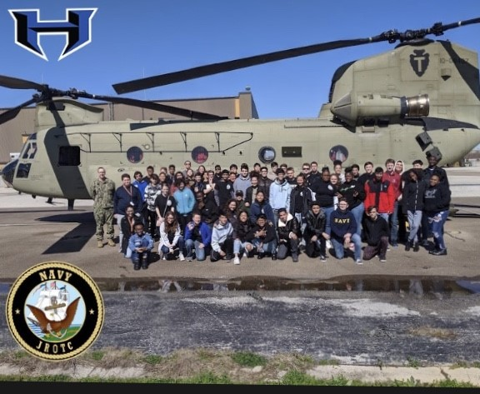

**FAMILY, FRIENDS, NEW ADVENTURES**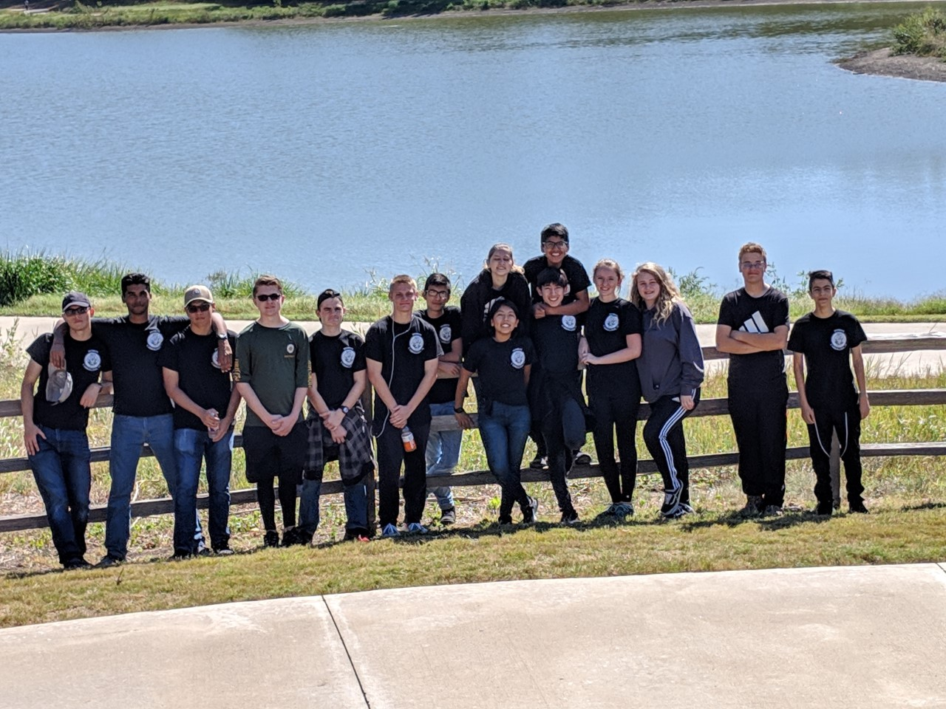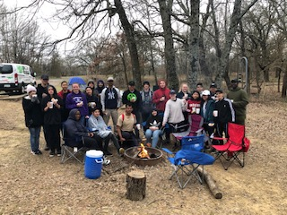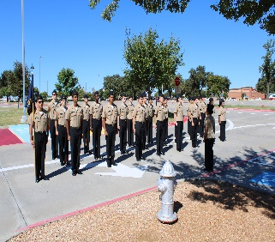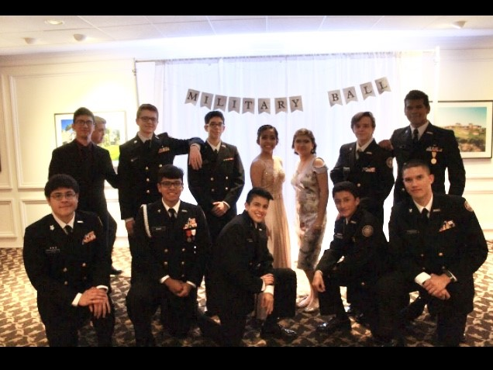

**\*JOINING JROTC DOES NOT MEAN MILITARY COMMITMENT\***

**\*ACTIVITIES TO INCLUDE, DRILL TEAMS, COLOR GUARD, MARKSMANSHIP, ACADEMIC TEAMS, FIELD TRIPS, CAMPING, SCHOOL/CIVIC ACTIVITIES, COMMUNITY SERVICE**

**\*BENEFITS INCLUDE P.E. CREDIT, NEW FRIENDS, NAVAL EDUCATION/TRADITIONS,   
ACCELERATED ADVANCEMENT INTO THE MILITARY, IF ENLISTING  
  
*WE EMPHASIZE LEADERSHIP, CITIZENSHIP, CONFIDENCE, SELF ESTEEM, FAMILY AND TEAMWORK\***

**SEE YOUR COUNSELORS ABOUT JOINING OR COME BY ROOMS 1580/1590 TO ASK ANY QUESTIONS!**



**https://drive.google.com/file/d/1VX6SEnufzU3JRNVozC6ttQYs--_cGFdt/view?usp=sharing**